“The legend of Y-29” v2.0
P-51 campaign by 1.JaVA_Sjonnie
IL2: 1946 version 4.08m or higher

Getting started
- Put the ZIP file in C: and extract. The path info is in the file.
- Start the game and select “pilot career” from the main menu.
- Select air force “USAAF”, then “The legend of Y-29” from the list.
- Set your rank.
- Set difficulty; this campaign can be flown at any difficulty level.
and off you go!

Flying the missions
You could choose a low rank if you would like to be guided to your targets by your squad mates.
Otherwise, any rank is fine. Just remember that if you want a mission to be successful, you need to complete your objectives.
Many missions have hidden targets only. Use your judgement and intuition and you will be able to finish them successfully.
RC
If you fly at full real, remember you have a radio compass (see RC) that shows you the way to the next waypoint in the mission.

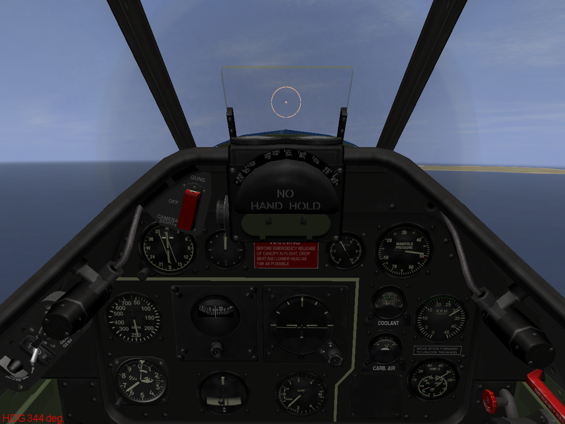

CREDITS
For immersion, good skins are indispensable. What would a blue- noser campaign be without blue noses?
These are the skin artists who contributed to this campaign:

1.JaVA_FD
1.JaVA_Serval
1.JaVA_Platypus
1.JaVA_FD
Canon_UK
Aero_Shodanjo
Hoarmurath
10tacle
Opa
FlugFarbe
Vp_media

Thanks guys! Your skins rock!

For making sure the campaign will work and to really get all the details right, you can’t do without testing. These are the guys that did a lot of hard work and found the flaws:

FoolTrottel
TimHolt
1.JaVA_Platypus

Thanks for the work you did guys! You added quality, no question. Thanks for bearing with me!

To get the historical details right, I used information from several sources including books by William Green, W. Grant, Manfred Griehl, Ken Delve, Julius Meimberg and many others.
The source that stands out is a website maintained by Scott Flugum:

http://352ndfg.com/Y-29/legend.htm

Thanks Scott!

